

Functional Specification Documentation

For
Pick and Pack

Version No.: 1.0
Date: 14th July 2016

Table of Content
1. Overview Details 3
1.1 Objective 3
2. Pick and Pack Manager – Open tab screen 0
3. Revised PO ETA Date listing 1
3. Outstanding SO Report 2

1. Overview Details

1.1 Objective

- Pick & Pack - to build a button to populate confirmed quantity to release quantity in pick & pack module to solve if the order need to release earlier than the confirmed delivery date.

- Revised PO ETA Date Listing.

- Outstanding SO Report.

2. Pick and Pack Manager – Open tab screen

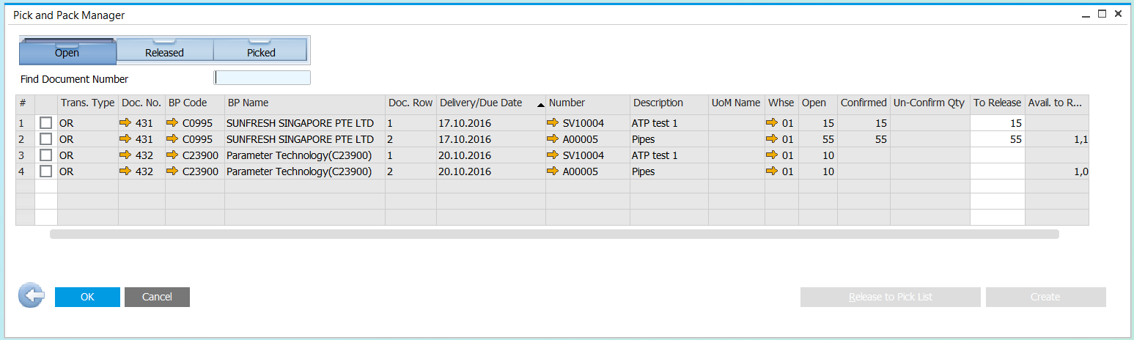
Copy Un-Confirm quantity

NO | Fields | System Action
 | Un-Confirm Qty | Get value from OSLD.CmfQty.  This will display only if Confirmed column is blank.
 | Click new button “Copy Un-Confirm Quantity” | Copy Un-confirm Qty to ‘To Release’ Column.  Copy only for those selected item in the pick list.

3. Revised PO ETA Date listing

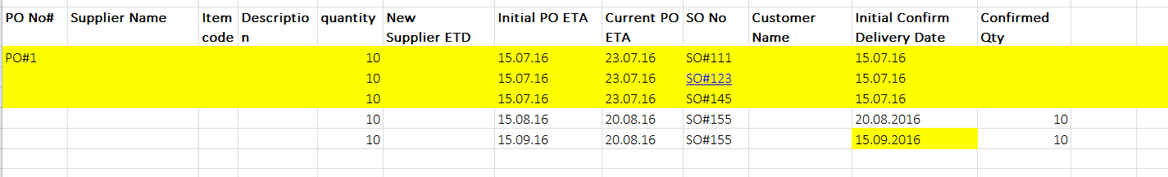

Parameter:
PO No:

Condition:
Reflected only when there is changes on PO ETA date / Production ETA date and the SO did not confirm Delivery details with the new PO ETA date.

NO | Fields | System Action
 | PO No / Prod No | OPOR.DocNum / OWOR.DocNum
 | Supplier Name | OPOR.CardName
 | Item Code , Item Description | POR1.ItemCode, POR1. Dscription / OWOR.ItemCode, OITM.ItemName
 | Quantity | POR1."Quantity" / OWOR.PlannedQty
 | New Supplier ETD | POR1.U_SupplierETD
 | Initial PO ETA | Get from history table for POR1.ShipDate
 | Current PO ETA | POR1.ShipDate/OWOR.DueDate
 | SO No | ORDR.DocNum/OWOR.OriginNum
 | Customer Name | ORDR.CardName/OCRD.CardName
 | Initial Confirm Delivery Date | OSLD.CfmDate
 | Confirmed Qty | OSLD.CfmQty

Test Case

- PO query should not reflect for the SO which status is cancelled.
- PO query should not reflect for the SO which status is closed.
- PO query should not reflect for the SO line item if delivery schedule detail is confirmed for the full quantity.
- PO query should reflect if delivery schedule confirmed for partial quantity.

Item Code: A00007, In-stock: 5, Available: 5
1. Create 1 SO
Item Code: A00007, Qty: 8
2. Confirmed Delivery Details schedule
Item Code: A00007, Qty: 5
3. Create new PO
Item Code: A00007, Qty: 10, to cater for the balance quantity for the SO.
4. Open PO created at #3, change the Supplier ETA date and update.

Expected Result
PO #1, Reflect for SO line item A00007 for the balance quantity.

- PO query should reflect if delivery schedule has not confirmed yet (Not yet confirmed full/partial)

Item Code: T0009, In-stock: 0, Available: 0
1. Create 1 SO,
Item Code: T0009, Qty: 10
2. Not yet confirmed delivery details schedule because of no stock.
3. Create new PO
Item Code: T0009, Qty: 15, to cater for the quantity for SO.
4. Open PO created at #3, change the Supplier ETA date and update.

Expected Result
PO #1, PO should reflect for SO.

- PO query should reflect for the SO line item which has yet delivery schedule

Item Code: A00005, In-stock: 1162, Available: 864
Item Code: SV10014, In-stock: 0, Available: 0
1. Create 1 SO
Item Code: A00005, Qty: 3
Item Code: SV10014, Qty: 5
2. Confirmed Delivery Details schedule for first item.
Item Code: A00005, Qty: 3
3. Create new PO
Item Code: SV10014, Qty: 10, to cater for the quantity for SO.
4. Open PO created at #3, change the Supplier ETA date and update.

Expected Result
PO #1, Reflect for SO line item SV10014 only.

- PO query should reflect (Split PO)

Item Code: SV10010, In-stock: 0, Available: 0
1. Create 1 SO,
Item Code: SV10010, Qty: 20
2. Not yet confirmed delivery details schedule because of no stock.
3. Create PO #1
Item Code: SV10010, Qty: 5
Create PO #2
Item Code: SV10010, Qty: 15
4. Open PO created at #3, change the Supplier ETA date and update for both PO.

Expected Result
PO #1, Reflect for SO
PO #2, Reflect for SO (Because quantity still not enough in PO #1)
- PO query should not reflect for SO line level if warehouse is different

Item Code: SV10006, In-stock: 0, Available: 0
1. Create 1 SO,
Item Code: SV10006, Qty: 10, Warehouse: 02
2. Not yet confirmed delivery details schedule because of no stock.
3. Create PO #1
Item Code: SV10006, Qty: 20, Warehouse: 01
4. Open PO created at #3, change the Supplier ETA date.

Expected Result
PO #1, Should not reflect (Because of different warehouse).

- 2 lines in 1 SO for the same item and confirmed delivery schedule for 1 line only

Item Code: SV10011, In-stock: 5, Available: 5
1. Create 1 SO,
Line: 0, Item Code: SV10011, Qty: 5
Line: 1, Item Code: SV10011, Qty: 8
2. Confirmed delivery details schedule for first line
Line: 0, Item Code: SV10011, Qty: 5
3. Create PO #1
Item Code: SV10011, Qty: 20
4. Open PO created at #3, change the Supplier ETA date and update.

Expected Result
PO #1, Reflect for only SO line 1 to cater the quantity.

- 2 lines in 1 SO for the different items and confirmed delivery schedule for 1 item only

Item Code: SV10011, In-stock: 5, Available: 5
Item Code: SV10012, In-stock: 0, Available: 0
1. Create 1 SO,
Line: 0, Item Code: SV10011, Qty: 5
Line: 1, Item Code: SV10012, Qty: 10
2. Confirmed delivery details schedule for first item
Line: 0, Item Code: SV10011, Qty: 5
3. Create PO #1
Item Code: SV10012, Qty: 20
4. Open PO created at #3, change the Supplier ETA date and update.

Expected Result
PO #1, Reflect for only SO line 1 (Item code SV10012) to cater the quantity.

- PO query should reflect if supplier ETA date changed as second time

Item Code: SV10015, In-stock: 0, Available: 0
1. Create 1 SO,
Item Code: SV10015, Qty: 5
2. No delivery schedule.
3. Create PO #1
Item Code: SV10015, Qty: 20
4. Open PO created at #3, change the Supplier ETA date and update.
Item Code: SV10015, Qty: 20, line ETA date=17.11.2016
5. Confirmed delivery schedule details.
Item Code: SV10015, Quantity: 5, Confirmed Delivery Schedule Date: 17.11.2016

Expected Result
PO should not reflect.

6. Open PO created at #3, change the Supplier ETA date as second time.
Item Code: SV10015, Quantity: 5, Confirmed Delivery Schedule Date: 19.11.2016

Expected Result
PO should reflect because supplier ETA date changed again.

Expected result for Initial PO ETA date column: 17.11.2016
(Need to capture the previous value of POR1.U_SupplierETD. Can we capture from the change log table?)

- Initial confirmed delivery date and confirmed qty

Item Code: SGDV-OFA01A, In-stock: 0, Available: 0
1. Create SO #476,
Item Code: SGDV-OFA01A, Qty: 10
2. No delivery schedule.
3. Create PO #517
Item Code: SGDV-OFA01A, Qty: 20, line ETA date=12.11.2016
4. Open PO #517 created at #3, change the Supplier ETA date and update.
Item Code: SGDV-OFA01A, Qty: 20, line ETA date=15.11.2016

Expected Result
PO #517, Confirmed delivery date = Empty, Confirmed Qty = Empty

5. Confirmed delivery date for SO #476
Item Code: SGDV-OFA01A, Qty: 5, Confirmed Date: 15.11.2016
6. Open PO #517 created at #3, change the Supplier ETA date and update as second time.
Item Code: SGDV-OFA01A, Qty: 20, line ETA date=17.11.2016

Expected Result
PO #517, Confirmed delivery date = 15.11.2016, Confirmed Qty = 5

- PO query should reflect (Consider earliest PO delivery date and quantity)

Item Code: SV10006, In-stock: 0, Available: 0
1. Create 1 SO,
Item Code: SV10006, Qty: 10
2. Not yet confirmed delivery details schedule because of no stock.
3. Create PO #1
Item Code: SV10006, Qty: 20, Delivery Date: 06.11.2016
Create PO #2
Item Code: SV10006, Qty: 20, Delivery Date: 08.11.2016
4. Open PO created at #3, change the Supplier ETA date and update for both PO.

Expected Result
PO #1, Reflect for SO
PO #2, Should not reflect (Because quantity still enough in PO #1 and delivery date is earlier then PO #2)

- PO query should reflect (Consider earliest PO delivery date and quantity)

Item Code: SV10006, In-stock: 0, Available: 0
1. Create 1 SO,
Item Code: SV10006, Qty: 10
2. Not yet confirmed delivery details schedule because of no stock.
3. Create PO #1
Item Code: SV10006, Qty: 20, Delivery Date: 09.11.2016
Create PO #2
Item Code: SV10006, Qty: 20, Delivery Date: 08.11.2016
4. Open PO created at #3, change the Supplier ETA date and update for both PO.

Expected Result
PO #1, Should not reflect for SO
PO #2, Reflect for SO (Because PO #2 delivery date is earlier than PO#1)

- PO query should reflect (Consider second earliest PO delivery date if quantity is not enough in earliest delivery)

Item Code: SV10006, In-stock: 0, Available: 0
1. Create 1 SO,
Item Code: SV10006, Qty: 25
2. Not yet confirmed delivery details schedule because of no stock.
3. Create PO #1
Item Code: SV10006, Qty: 20, Delivery Date: 09.11.2016
Create PO #2
Item Code: SV10006, Qty: 20, Delivery Date: 08.11.2016
4. Open PO created at #3, change the Supplier ETA date and update for both PO.

Expected Result
PO #2, Reflect for SO (Because PO #2 delivery date is earlier than PO#1)
PO #1, Reflect for SO to cater the balance 5 qty (Because quantity is not enough in PO #2)

Outstanding SO Report

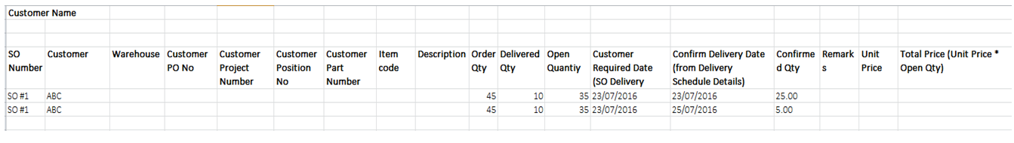

This report will show only:
  - SO line item that has yet to check availability
  - SO line item with default future date 31/12/3000 (this default date can be changed by Administrator after system go live)
NO | Fields | System Action
 | SO Number | ORDR.DocNum
 | Customer | ORDR.CardName
 | Warehouse | RDR1. Whse
 | Customer PO No | ORDR.NumAtCard
 | Customer Project Number | ORDR.U_ProjectNo
 | Customer Position No | ORDR.U_PositionNo
 | Customer Part Number | RDR1.SubCatnum
 | Item Code | RDR1.Itemcode
 | Description | RDR1. Dscription
 | Order Qty | RDR1.Quantity
 | Delivered Qty | RDR1."DelivrdQty"
 | Open Quantity | RDR1."OpenQty"
 | Customer Required Date | RDR1.ShipDate
 | Confirm Delivery Date | OSLD.CfmDate
 | Confirmed Qty | OSLD.CfmQty
 | Remark | ORDR.U_RemarkSA
 | Unit Price | RDR1.Price
 | Total Price | RDR1.LineTotal

